Green Key Folder

ESTABLISHMENT’S NAME HERE

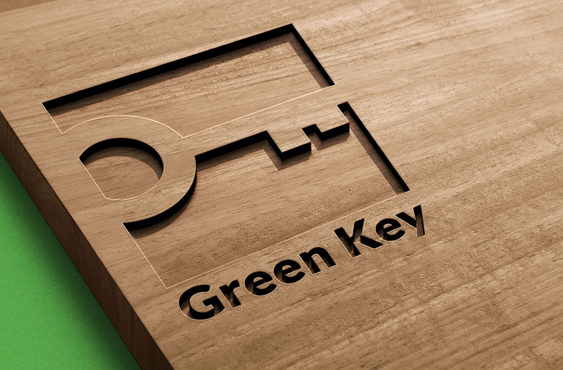

LIST OF CONTENTS

ENVIRONMENTAL MANAGEMENT
1.2 Establishment’s written sustainability policy
1.3 Annual sustainability goals and action plan
1.6 Carbon footprint calculations
(1.10 Certificate of carbon neutrality)

STAFF
2.1 Minutes of meetings between the management and environmental manager
2.3 Overview of staff meetings/training sessions on environmental/sustainability issues

GUEST INFORMATION
3.1 Pictures of locations of Green Key certificate and sign
3.4 Sustainability communication materials aimed at guests:
- Sustainability information provided in room tv / tablet / folder
- Sustainability related posts in social media
- Sustainability campaigns etc.

WATER
4.1 Total water consumption in the past year
4.4 Latest water flow measurements of customer and staff showers
4.5 Latest water flow measurements of customer and staff hand basin taps

CLEANING
5.3 List of detergents in daily use, and their eco labels
5.5 List of soft tissues in daily use, and their eco labels
5.6 List of dishwash detergents, and their eco labels
5.7 List of laundry detergents, and their eco labels
(5.14 List of hand soaps for customer use, and their eco labels)
(5.15 List of cosmetic products for customer use, and their eco labels)

WASTE
6.1 List of types of waste collected
6.3 Instructions for customers and staff regarding sorting and handling of waste
6.4 Service log of refrigerating units, including information on added coolants and the name of service provider
6.10 Summary of quantity (by type) of waste collected during the previous year

ENERGY
7.1 Total energy consumption in the past year

ELINTARVIKKEET
8.1 List of organic / fairtrade / locally produced foodstuffs in regular use
8.3 List of non-alcoholic organic / fairtrade / locally produced drinks offered to guests:
1) tea, coffee
2) juice, soft drink, or milk
8.4 List of organic / locally produced beer, wine, or cider/long drink available to customers (if the establishment has a licence to sell alcohol)
8.8 Action plan for combatting food waste
(8.11 Action plan for monitoring food waste)

INDOOR SPACES
List of materials, paints etc. used in renovations during the past year, including their eco labels/ ratings

GREEN AREAS
10.1 List of chemical pesticides, herbicides, insecticides, and fertilizers in use
10.4 List of biodiversity-enhancing actions carried out during the past year

